Receipt Image Capture
Receipts are required for all purchases. There a several different ways you may acquire credit card receipts. They can be easily converted to electronic form, stored, and uploaded online to JP Morgan’s Smart Data system. Below is a list of items that will help you capture and store your credit card receipts.
Receipt Storage/Google Drive
Every Doane employee has their own Gmail account. With this, you have access to Google Drive, which allows you to save files in the cloud for easy retrieval anywhere. To access a Google Drive account, open your email and select the icon in the screen shot below.
2
1
- Click on this icon to access the drop down box for the various Google applications.
- Click on this icon to bring up your Google Drive account.

From here you can set up the Google Drive account with folders to store your receipt images. Right click within the body of the Google Drive account and select “new folder” and label it “credit card receipts” or something similar. You can create subfolders within this main folder if you want to separate the folders by month. This is recommended if you do a lot of card purchasing. See below for an example of how the Google Drive will look.

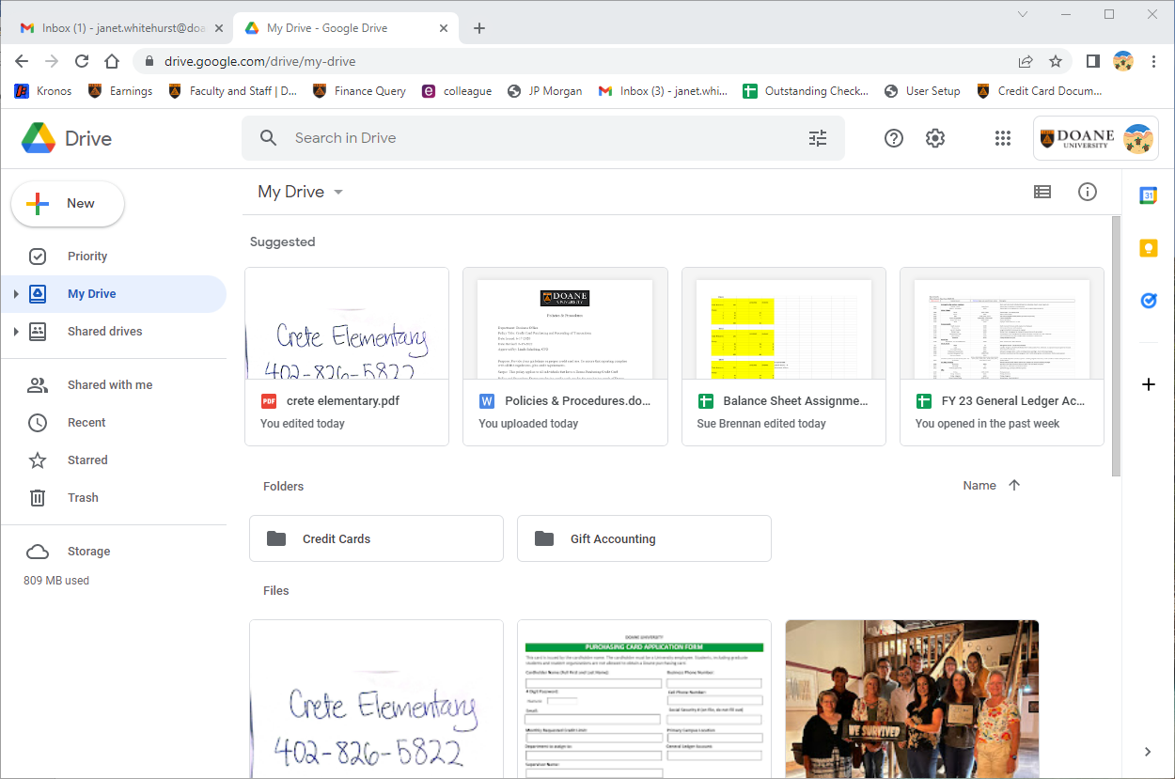

You will need the Google Drive app for your smartphone (if applicable). You will need to sign into the app with your Doane email and password to sync the Google Drive folder with the account on the cloud. This will create the file that will allow you to upload the images to your transaction listing on SmartData directly from your smartphone.

Physical Receipts
- Smartphone App – there are a variety of free apps that allow you to take a picture of a receipt, name it and save it to your Google Drive account in PDF format.
- Scan – You can also scan receipts and save them to the desired folder on your computer and then upload them to Google Drive folder from there, or directly to the SmartData website from your computer.

Digital Receipts
- Online Documents – you can download invoices from a variety of sources such as an email attachment or company website.
- Email – when a receipt is emailed in the body of the email (not an attachment), you can select print and choose the “save as PDF” option under the destination in your print preview screen. After saving to your computer you can upload to drive first or directly to SmartData.

